(Note: Applications are required 10 days in advance for review. If event is canceled or not otherwise held, granted funds must be refunded)
City of Stanton Tourism and Convention Commission
PO Box 370
Stanton, KY 40380
Grant Application
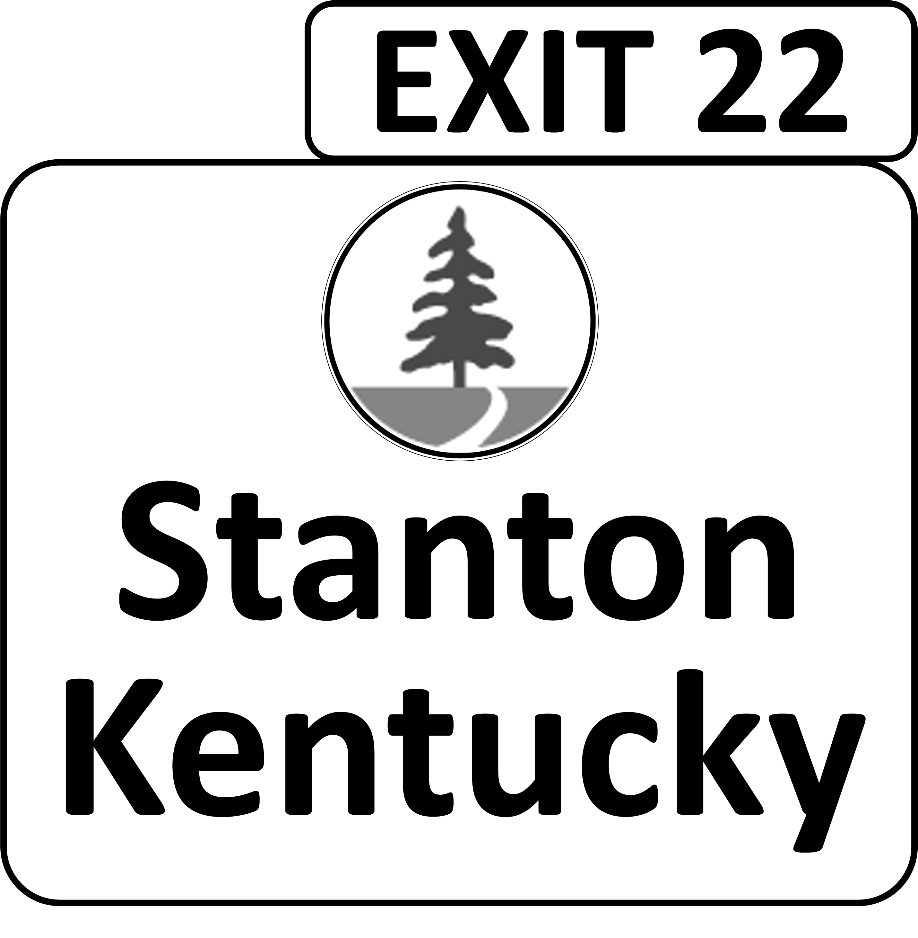
Organization Name: _____________________________________________________ Date: ________________
EIN or SSN Registered with Secretary of State: ____________________________________________________________
Address: __________________________________________________________________________________________
__________________________________________________________________________________________
Telephone Number: _________________________________________________________________________________
Director/Contact Person: _____________________________________________________________________________
Annual Operating Budget: ____________________________________________________________________________
Other Sources of Income: ____________________________________________________________________________
Total Income: ______________________________________________________________________________________
Amount Requested: ____________________________________________________ Date of Event: ________________
For What Purpose Would The Grant Be Used: _____________________________________________________________
__________________________________________________________________________________________________
__________________________________________________________________________________________________
How Would This Impact Tourism and Travel in Stanton: _____________________________________________________
__________________________________________________________________________________________________
__________________________________________________________________________________________________
By What Date Are Funds Needed: ______________________________________________________________________
Additional Required Documents:
- Event Summary
- Press Package
- Detailed Current Budget
- Last Year’s Profit/Loss or Equivalent (waived with Commission approval)
- After Action Report

Organization Signature: _______________________________________________ Date: ________________
Revised March 2018

